**Basel 3 Regulation**

Basel III introduced a non-risk-based leverage ratio as a backstop to the risk-based capital requirements. Banks are required to hold a leverage ratio in excess of 3%, and the non-risk-based leverage ratio is calculated by dividing Tier 1 capital by the average total consolidated assets of a bank.

In 2015, the Tier I capital requirement increased from 4% in Basel II to 6% in Basel III. The 6% includes 4.5% of Common Equity Tier 1 and an additional 1.5% of additional Tier 1 capital.

Basel III is an international regulatory accord designed to improve the regulation, supervision, and risk management of the banking sector.

A consortium of central banks from 28 countries devised Basel III in 2009, mainly in response to the financial crisis of 2007–2008 and the subsequent economic recession.

Basel III is part of an evolving framework that adapts to changes in national economies and the financial landscape.

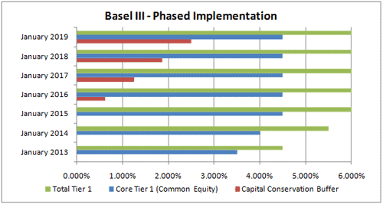

**Securities and exchange commission (SEC) regulations**

The U.S. Securities and Exchange Commission (SEC) is an independent federal government regulatory agency responsible for protecting investors, maintaining fair and orderly functioning of the securities markets, and facilitating capital formation. It was created by Congress in 1934 as the first federal regulator of the securities markets.

The SEC was established by the passage of the U.S. Securities Act of 1933 and the Securities and Exchange Act of 1934, largely in response to the stock market crash of 1929 that led to the Great Depression.

The SEC consists of five divisions and 23 offices.

the agency maintains confidence in America’s financial markets worth more than $100 trillion.

the agency governs more than 28,000 entities in the financial industry, including mutual fund and ETF providers, ensuring prospectus and other disclosures paint a clear picture of investment risks and other factors.

**Dodd – Frank wall street reform and consumer protection act**

The Dodd–Frank Wall Street Reform and Consumer Protection Act, signed into law in July 2010, made reforms to financial regulations. The following pages provide an overview of the major provisions of the Act.

Dodd-Frank will prevent the excessive risk-taking that led to the financial crisis. The law also provides common-sense protections for American families, creating new consumer watchdog to prevent mortgage companies and pay-day lenders from exploiting consumers.

Dodd–Frank, investment advisers were not required to register with the SEC if the investment adviser had fewer than 15 clients during the previous 12 months and did not hold himself out generally to the public as an investment adviser.

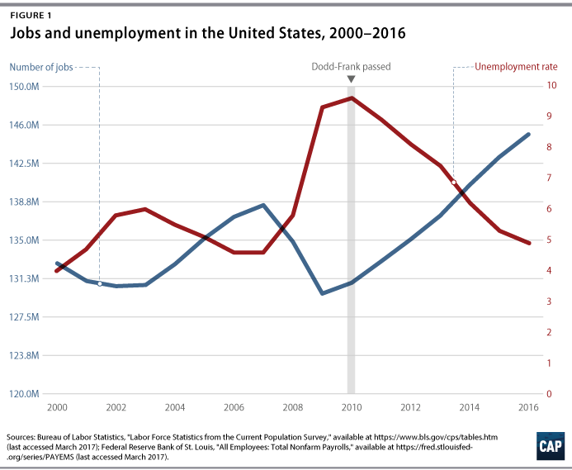

The Great Recession has had a profound impact on the U.S. economy. Between 2007 and 2009, 8.6 million jobs were lost, resulting in a sharp increase in unemployment rates. In 2010, the average unemployment rate was more than double that reported in 2007: 9.6 percent versus 4.6 percent. The U.S. economy has added millions of jobs since the economy bottomed out in 2009; today, the unemployment rate stands at 4.7 percent.

**Sarbanes – Oxley Act (SOX)**

The Sarbanes-Oxley Act (SOX) defines the requirements for the integrity of source data related to financial transactions and disclosures.

SOX compliance is the act of adhering to the financial reporting, information security and auditing requirements of the Sarbanes-Oxley (SOX) Act, a US law that aims to prevent corporate fraud.

The average organization spends more than USD 1 million on SOX compliance efforts every year.

Regulatory compliance has a big say in how businesses design and develop their systems. A major compliance requirement for many businesses is the Sarbanes-Oxley Act of 2002 (SOX).

